Sprint 2 retrospective

By Gerardo Flores, Ahram Kim – CCP Tour App

# Sprint demo

On this second sprint for our CCP Tour App, we made visual hierarchy app design for upcoming spring, made three navigator tabs for the user to find the info easily, and started to build the ‘home’ tab

# Definition of done

* All acceptance criteria have been met
  + We designed visual hierarchy app design
  + We made three navigator tabs
  + We start the ‘home’ tab for the user
* All the automated tests for the user story run without failing and any defects
* Code unit tested
* Pair programming is done
* Build pushed to demo server

# Burndown chart and velocity

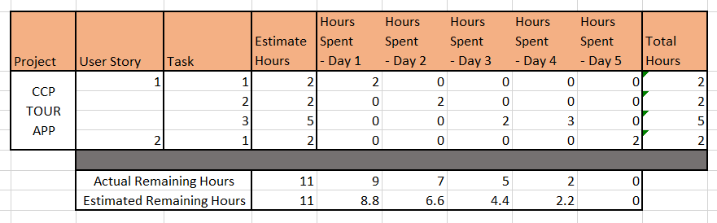

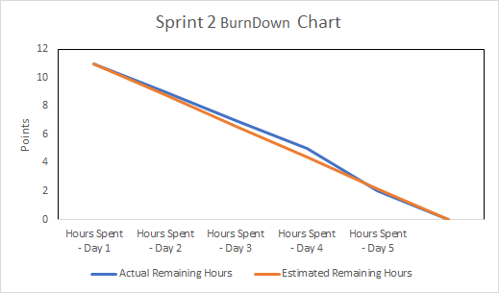

# Defect removal activity

Publish metrics for each defect removal activity per Definition of Done

# Project Name: CCP TOUR APP

Team member (print/sign):_____Ahram Kim_____________________________________________

Team member (print/sign):_____Gerardo Flores__________________________________________

Sponsor name (printed): Ashley Beasley

**Sponsor signature:**___________________________________________________________________

Date: 09/12/2018

Sponsor checklist:

* I have seen the user stories completed demoed and they appear to work and meet the DOD
* Team has provided me with a burn down chart and velocity

